**Task4**

**Areas**

Description:

The topics we covered in this program is:

Control Structure,

If selection statement,

If else... selection statement,

Counter Control iteration,

For iteration statement,

This program takes an arithmetic choice 1, 2, 3, 4 and 5

By choice of 1, it will ask for radius of a circle and find area of that circle.

By choice of 2, it will ask for radius of circle and find out perimeter of circle.

By choice of 3, it will ask for length and width of rectangle and find out area of rectangle.

By choice of 4, it will ask for length and width of rectangle and find out perimeter of rectangle.

At the end it has choice of 5 to quit program.

Code:

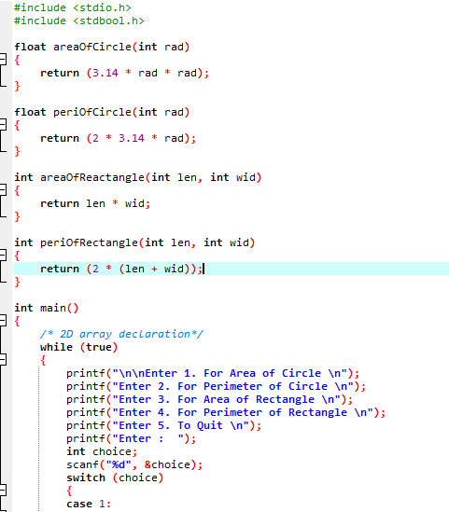

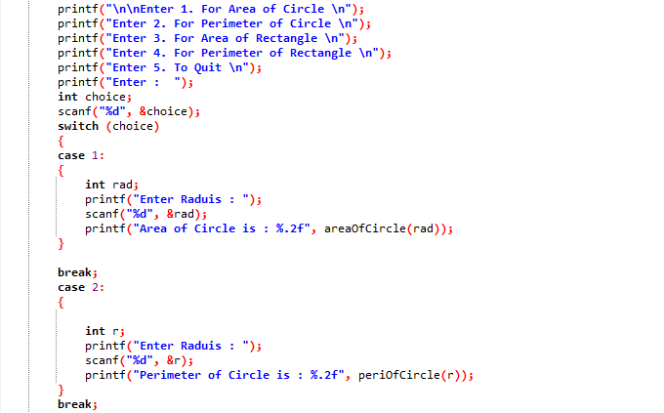

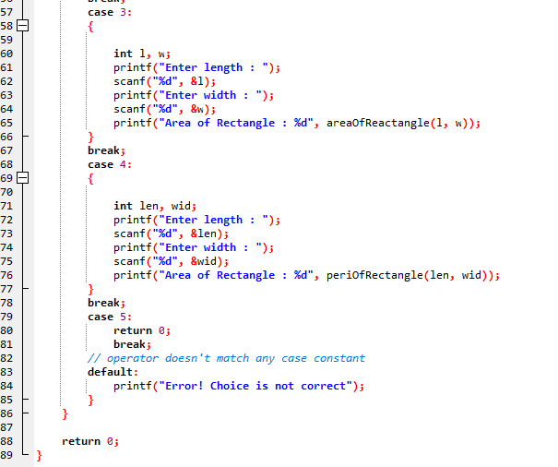

**OUTPUT:**

